Strings
8-11-25
Aim – Write a program to demonstrate string functions and another to check if the entered string is palindrome or not and output the result.
Theory –
Length function counts characters in a string until the null terminator, excluding it. Indexing allows accessing each character using its position starting from zero, enabling reading, modifying, or traversing the string in C programming language. Indexing a string allows us to treat it as an array of chars and perform the required functions. We also saw functions that are used to add two strings, reverse a string and check which one is greater.
A1.
#include<stdio.h>
#include<conio.h>
#include<string.h>

void main(){
char s[100], c[100];
printf("Please enter the string: ");
gets(s);
int len = strlen(s);
printf("Length %d\n", len);
strcpy(c, s);
printf("Copy is %s\n", c);
strcat(c, s);
printf("The concated string is (C is changed) %s\n", c);
if (strcmp(c, s) == 0)
printf("The String are same\n");
else if (strcmp(c, s) > 0)
printf("The String c is greater than s\n");
else
printf("The String s is grater than c\n");
strrev(s);
printf("The reversed String is: %s", s);
}
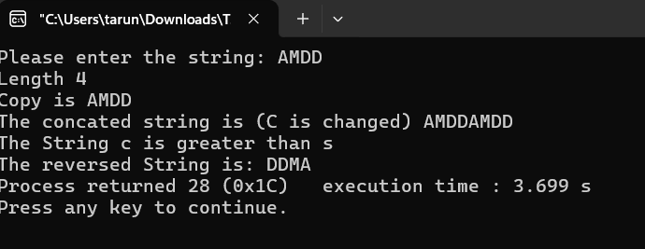
A2.
#include<stdio.h>
#include<conio.h>
void main(){
char s[100];
printf("Please enter the string: ");
scanf("%s", s);
int pal = 1;
int len = 0;
while (s[len] != '\0') {
len++;
}
for(int i = 0; i<len/2; i++){
if (s[i] != s[len - i - 1]) {
pal = 0;
break;
}
}
if (pal == 1){
printf("Palindrome String");
} else {
printf("Not a Palindrome String");
}
}
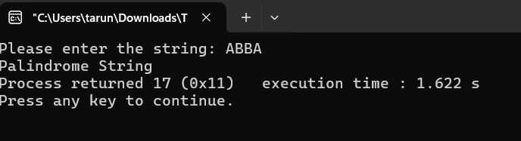
Conclusion
In conclusion, string operations such as checking for palindrome, copying strings, and finding their length help in understanding how strings are handled in C. These programs strengthen the concepts of character arrays, indexing, and the importance of the null terminator '\0', enabling efficient manipulation and processing of textual data. We also looking into various string functions and their uses.

